Near-Real Time Analytics for Project Convergence 21

Matthew D. Smith
The Research and Analysis Center (TRAC)-Monterey
700 Dyer Rd
Monterey, CA 93943
831-656-7578
matthew.d.smith255.mil@army.mil

29 April 2022

Abstract
During operational experiments, tactical networks can generate large volumes of data in the form of packet capture data, system logs, instrumentation measurements, and even manual data entries. As tactical networks have evolved from low-throughput radio systems to high-capacity IP-enabled networks, this data can easily exceed 1 TB per day, making it difficult to process and extract insights in near-real time to track exercise event and inform upcoming exercise decisions. This paper presents a unified assessment framework for applying data analysis methods to conduct in-stride analysis of experimentation data for the Army's Project Convergence. We apply data reduction, network analysis, sentiment analysis, and data visualization techniques to process and analyze large volumes of network and natural language data to extract meaningful insights in near real time. We demonstrate how this analysis can deliver key operational insights during experiment execution, including assessment of tactical network health and performance, highlighting system performance, and uncovering issues or concerns within the system of systems under evaluation.

INTRODUCTION
Project Convergence (PC) is an annual warfighting experiment to test the Army’s ability to incorporate emerging technologies and integrate with the joint force. First launched in 2020, PC has evolved into a campaign of learning that aims to set modernization direction, inform investment decisions, and build trust in technologies (TRAC, US Army, 2020). At its core, PC centers around the integration of artificial intelligence (AI) and machine learning (ML) at the tactical level and the ability to connect and integrate systems from all Services into a single reliable and resilient network, a concept known as Joint All Domain Command and Control (JADC2) (Hoehn, 2022). In this respect, PC is similar to other JADC2 and AI integration efforts from across the Department of Defense (DoD), such as the Navy’s Project Overmatch, the Marine Corps’ Global Analytics Platform, and the Air Force’s Air Battle Management System (Johns Hopkins APL, 2021).
As a large-scale warfighting experiment, PC brings together over one hundred early science & technology capabilities in a field environment to learn about the specific challenges and capabilities of an AI-enhanced battlefield. To conduct the experiment, these systems are connected by a series of tactical networks and observed by Subject Matter Experts and Observer Analysts (OAs), generating large volumes of data in the form of packet captures, system logs, sensor measurements, and even natural language comments. As tactical networks have evolved from low-throughput radio systems to high-capacity IP-enabled networks (Kenneth D Renard, 2015), this data can easily exceed 1 TB per day, making it difficult to process and analyze the data.
Despite the data processing challenges, it is crucial for the Army’s analytic community to be able to extract data-driven insights and observations in near-real time to track exercise event and inform upcoming exercise decisions. Not only does this “In-Stride Analysis” inform interested stakeholders on the performance of the various systems under evaluation, but it also helps to guide the execution of the exercise. By highlighting issues or identifying collection gaps, in-stride analysis can help ensure successful execution of the experiment, leading to improved learning and better support of the experiment’s ultimate learning objectives, as shown in Figure 1.
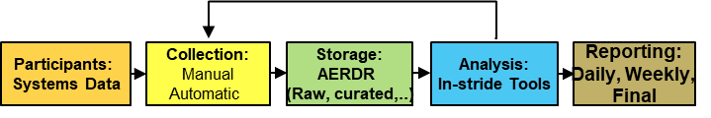
Figure 1: Overview of the methodology for providing In Stride Analysis that provides feedback to guide experiment execution and ensure successful data collection.

This paper describes a methodology for delivering in stride analysis (forth box in blue in Figure 1) during Project Convergence 21 (PC21). This approach involves two key contributions: (1) a methodology that allows for the near-real time (hours to days) reduction and analysis of large streaming network data sets from warfighting experiments, and (2) the development of a set of visualizations and analytic products that deliver insights relevant to the successful execution of the experiment.
This paper is organized into four sections. The initial section outlies how the team scoped the problem to include the limitations and assumptions made. After reviewing the scope and limitations of our approach, the next section then presents the in-stride analysis methodology, highlighting the data analysis methods, processes, and tools employed to go from raw exercise network and observer data to finished analysis in a short time period to inform decision makers. The Results section then illustrates a series of data visualizations and analytic results that help to track exercise events, highlight issues, and provide insights on systems under evaluation. These include timing analysis charts to highlight key timing metrics, network criticality graphs to identify the most critical systems, an execution checklist tracker to visualize the performance of exercise threads, and a sentiment analysis tool to extract insights from manually collected observer comments. Combined, these techniques enable analysts to deliver near real-time analysis and visualizations that are tailored to delivering the types of insights needed to ensure successful execution of the PC experiment.

SCOPE
As a large-scale warfighting experiment, PC presents many data collection and processing challenges that are beyond the scope of this research. In addition to the large volumes (TBs) of daily network traffic, there is also a high degree of data variety with over 100 unique technologies under evaluation, many with unstructured and non-standardized data formats. This has two key implications for our approach. First, this research does not attempt to reduce and process all collected data. Rather, we focus on techniques to identify targeted subsets of the collected data, through tagged data collection as well as through data correlations to identify the time windows of interest. Second, we deliberately design and integrate manual data collection into the in-stride methodology. In many cases, the network data and system logs were not available for multiple days after event execution due to the logistical challenges such as the manual transfer of hard drives or the reduction of exercise data sets using proprietary data reduction methods by the Army’s test and evaluation community. Hence, while we do explore the use of more modern data processing methods to reduce large network data sets on a quicker time scale, we primarily speed the data analysis timeline via smarter targeting to subsets of interest, augmented and guided by manual data collection.
Another key constraint on this research is the fact that most of the exercise results are classified at the Secret level. Hence, this research aimed to build a methodology that utilized the data science tools available on that platform. As a results, our methodology uses many lightweight and open-source data science tools from the python and R ecosystems. While there is an opportunity to apply advanced cloud analytics or utilize HPC capabilities to streamline the data reduction process, those tools were not available for this analysis.
While most of the actual PC21 results are at the Secret level, this paper presents notional examples using synthetic data that is drawn from random distributions and not correlated with actual experiment results. This allows us to share the key findings and examples of the key analytical products at the unclassified level.

METHODOLOGY
The in-stride analysis methodology is modeled after the 5-phase data analysis process developed by the US Army Research Laboratory’s Computational and Information Sciences Directorate (ARL-CISD) to utilize high-performance computing (HPC) to build a system-of-processes to reduce large volumes of tactical network data into a consumable format for analysis (Kenneth D Renard, 2015). The ARL-CISD process can be summarized as (1) extract raw data, (2) reduce raw data, (3) run HPC to produce a query-able data model, (4) run quality assurance reports, and (5) deliver data ready for analysts and evaluators. While the ARL-CISD process provides a useful framework to guide the reduction of exercise data, the in-stride analysis for PC differs in two respects. First, we built a methodology that does not rely on the use of HPC due to the constraints outlined in the Scope section. Second, we carry the analysis forward one additional step to deliver insights from the data rather than simply making the data available for analysis. Given those differences, we developed a 4-step in stride analysis methodology depicted in Figure 2.

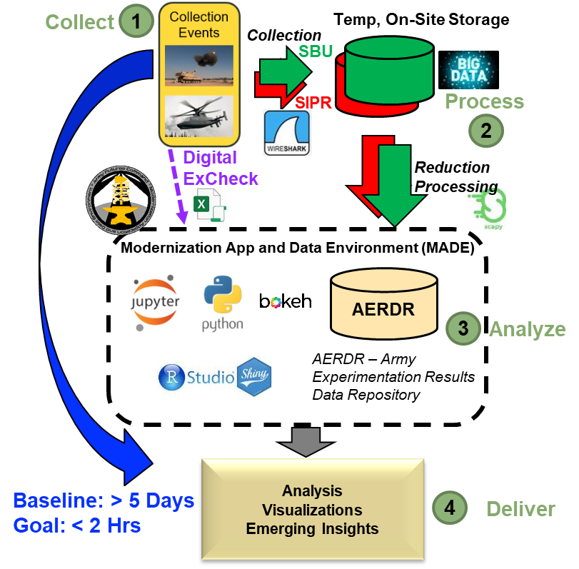
Figure 2: In-Stride Analysis methodology used to deliver insights in near-real time during event execution.

In the Collect step, raw data is captured from the field experiment, primarily through a series of packet capture devices employed on each region of the tactical network. Once the network data is harvested, it is then transferred to storage location for further processing and to be combined with other instrumented data collection such as system logs or sensor measurements. In parallel to the packet capture, we also integrate manual collection through a Digital Execution Checklist (Digital ExCheck). In our scheme, observers within the Execution Control (EXCON) centers are manually logging times using an Excel macro to record when an execution checklist step happened. While the use of manual collection introduces limitations on the precision and reliability of the collected data, the resulting collection enables insights on a much quicker timescale while also providing timing windows to guide the processing of the larger network data sets.
In step 2, Process, data processing and reduction methods are used to reduce terabytes of raw collected field data to a consumable data product that can be used by analysts and evaluators. This step serves not only to reduce the data to file sizes that are more usable, but also to extract the tactical data link (TDL) messages that are embedded within the network data. These TDL messages encode the information exchange between tactical systems and contain the data fields that allow for analysis regarding factors such as sensor to shooter timing, target location errors, sensor performance, or decision agent performance. The result of step 2 is thus a query-able data model that is accessible to analyst and evaluators across the community.
In step 3, Analyze, analysts are able to apply a variety of data science methods to analyze the collected data. While this process does not rely on the use of HPCs, we did make use of a cloud analytics platform known as the Army’s Modernization App Development Environment (MADE), which provides a modern suite of data analysis tools including R and python. This environment was available on SIPR networks, and thus allowed analysts to easily aggregate multiple exercise data sets to develop deeper insights.
In the final step, Deliver, analytical results are shared with the community of interest to deliver key observations, operational insights and initial findings during experiment execution. In particular, we leverage the data science capabilities of the MADE environment including the python bokeh package and the R-Shiny tool to produce interactive web applications which provide a powerful means of communicating insight to stakeholders while also eliciting feedback that can drive exercise planning decisions.
This methodology ultimately provides a quicker way to collect and reduce data to a consumable format needed for analysis, as well as the tools needed to conduct and share the analysis. By streamlining the collection of key timing and performance data, developing scripts to process and reduce exercise data to consumable data models, leveraging the MADE environment to aggregate and analyze results, and delivering web-based dashboards to communicate insights, this methodology enables data-driven insights that can ensure successful execution of Army experiments. The next section describes how this analysis can inform specific interest areas for PC, including sensor to shooter timing, execution checklist progression, network criticality, and sentiment analysis of system performance.

RESULTS
This section illustrates how the in-stride analysis methodology is used to gain insights into the execution of the PC21 Use Cases. PC is designed under the umbrella of a series of Mission Threads, shown in Figure 3. These mission threads are not focused on one particular technology or one aspect of the Army’s mission, but looks at how AI and other emerging technologies can transform how the Army conducts a variety of missions, from target detection, to fires synchronization, to missile defense and even sustainment operations. Under each mission thread category are one or more use cases, which are tactical vignettes, mostly designed as a series of sensor to shooter engagements where we can evaluate how well AI, Machine Learning and other technologies speed up decision making in terms identifying and characterizing threats and pairing capabilities against those threats.
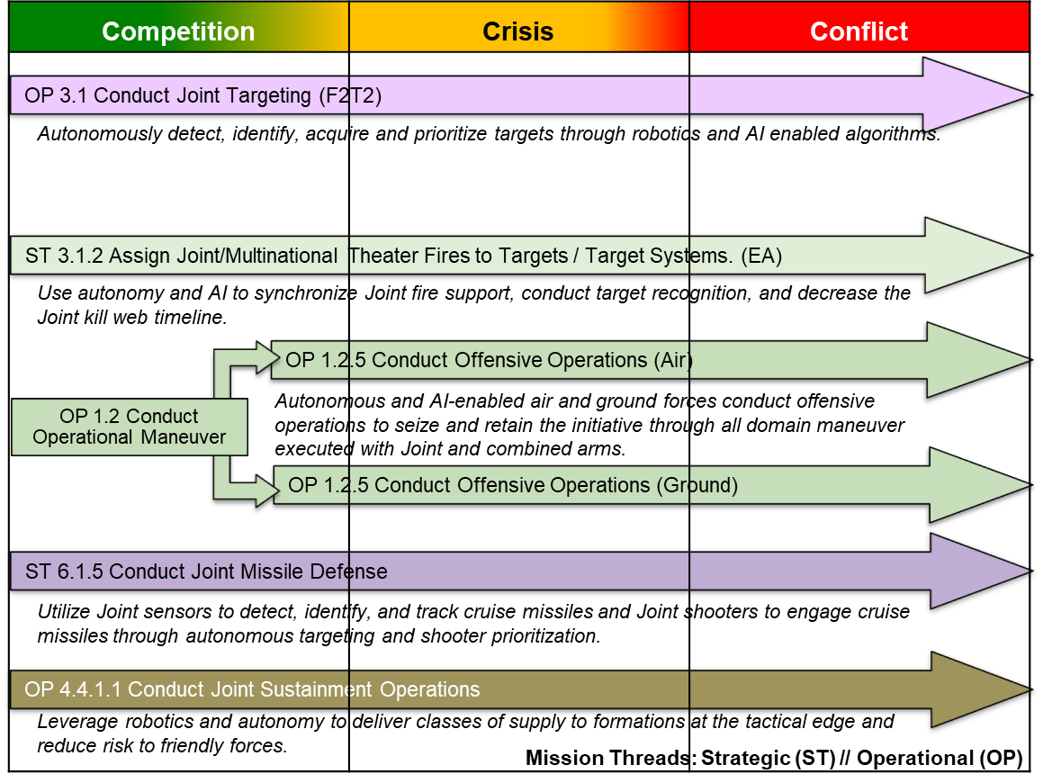
Figure 3: Project Convergence Mission Threads, which serve as the foundation for experiment execution.
This section illustrates how in stride analysis is used to develop visualization and analysis products that provide insight into the execution various aspects of the PC21 use cases. In particular, we demonstrate new ways to display and analyze the timing of sensor to shooter engagements, the efficiency of use case execution, the criticality of network nodes, and the sentiment of observer comments on the performance of key systems.

Timing Analysis
One of the primary objectives of PC is to demonstrate how these emerging technologies can help shorten the sensor-to shooter-kill chain when integrated at the tactical level. This is mainly driven by the need to posture the Army for the future operating environment where everything is digitized and decisions need to be made in minutes or seconds rather than hours or days (US Army TRADOC, 2018).
PC21 measures speed by considering the time required to conduct the Detect-Decide-Deliver-Assess (D3A) phases. As illustrated in Figure 4, this ordering differs from traditional Army Targeting doctrine, which places Decide before Detect. This change in PC is partly due to the design of use cases where we first detect a pre-determined target then then progress through a linear process of deciding which shooter capability to pair against that threat. However, this is also can be seen as a paradigm shift due to the impact of AI systems. In the traditional setting the decision step is such a time and resource intensive task that it had to be done ahead of time. However, with AI decision support systems integrated into the tactical formations, units can process large volumes of streaming information from a continuously interacting web of sensors and shooters and instantly provide optimal decision recommendations. Hence, tactical units have the freedom to make targeting decisions during engagements while keeping the sensor to shooter time small.
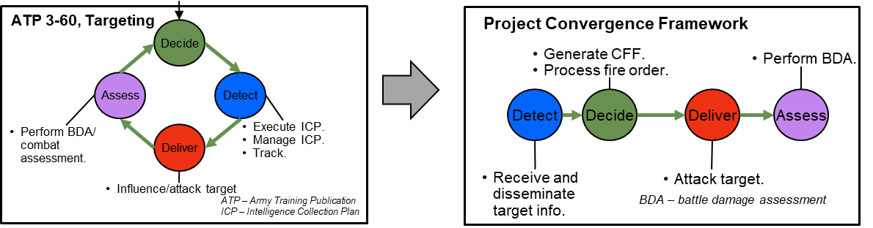
Figure 4: The doctrinal targeting methodology (left) provides the basis for the PC analysis framework (right) which uses the Detect-Decide-Deliver-Assess framework to monitor the timing and evolution of PC21 use cases.
That leads to question of how to process and display the timing information to illuminate system performance. Using the Digital Execution Checklist data sets discussed in the Methodology section, along with python’s bokeh visualization library, the development of Arrow Charts were a useful way to illustrate the timing information of the D3A phases for sensor to shooter engagements. An example is illustrated in Figure 5.
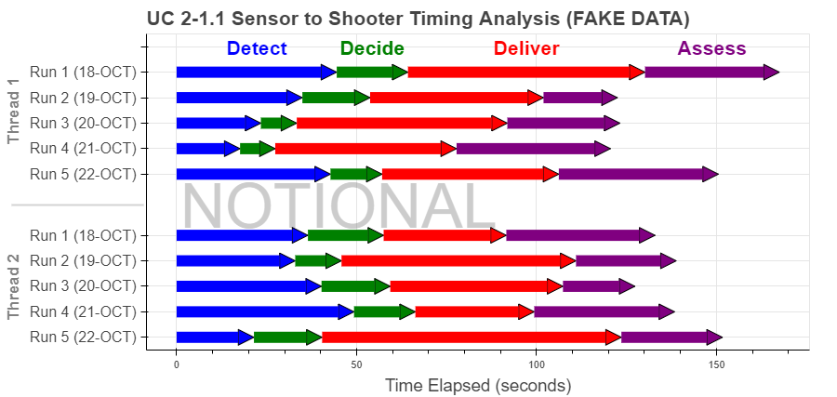
Figure 5: Timing analysis “Arrow Charts” showing the notional timing of multiple runs of multiple use cases through the D3A phases of a sensor to shooter engagements.
This arrow chart formulation provided numerous benefits when provided as part of the in-stride analysis products. First, it yields enhanced understanding of the performance of AI systems and algorithms by viewing how their contribution as sensors or decision nodes impacts the overall timing of the sensor-to-shooter engagement. It also provided a convenient framework to view trends across runs. This became useful when evaluating how AI performance and timing was affected by runs that simulated the effects of a Denied, Disrupted, Intermittent, and Limited-Bandwidth (DDIL) environments.
Second, this graphic became a useful tool to identify issues or anomalies during event execution. In cases where a given phase took much longer than it had in previous iterations, that could serve as a signal of potential issues that needed to be addressed. Since this graphic could be built using only the Digital ExCheck excel documents, it could be generated within an hour of the end of experimentation, meaning these insights were available in time to implement potential changes for the next day.
Finally, the arrow chart framework was useful beyond the context of sensor to shooter engagements. For example, in the use case supporting the sustainment mission thread, the phased arrow charts could be tailored to represent the steps needed to conduct autonomous resupply, including the autonomous delivery of ammo or the utilization of repair parts. In other cases, user interactions of the interactive graphics could reveal timing data and anomalies among sub-tasks within each phase, making the graphics more informative to exercise planners, test engineers, and system owners.

Execution Checklist
While the Digital ExCheck documents provide the key timing data to visualize and analyze the timing of the D3A phases of PC21 use cases, the complete ExCheck documents captured up to 300 unique timing events of each use case run. Hence, these documents enable a much richer analysis and picture of the use case execution. This is illustrated by the Execution Checklist Collection Summary diagram, shown in Figure 6.
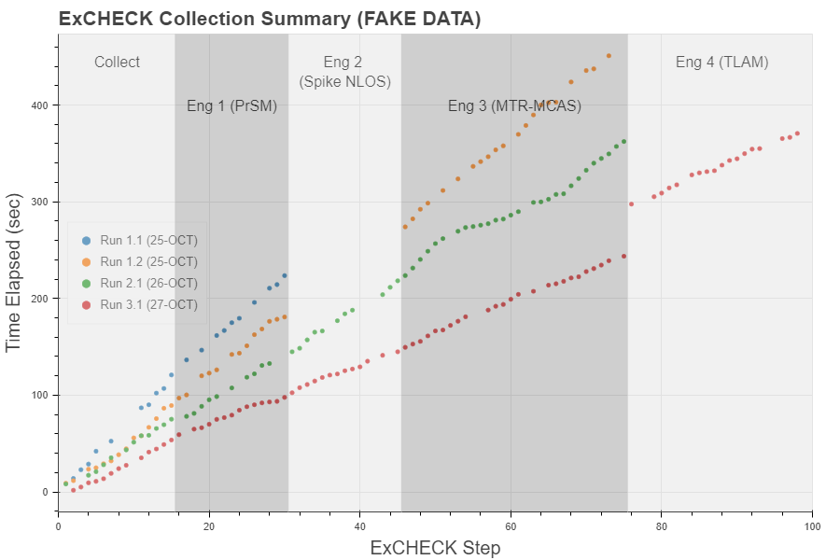
Figure 6: A notional Use Case Execution Collection Summary diagram, which uses the timing of execution checklist tasks to illuminate trends within and between exercise runs.

This diagram, developed in coordination with several leaders from the PC data collection and analysis community, proved to be a simple yet powerful tool used in the daily summary briefs. One key benefit was to illustrate the issues and pain points for each use cases. For example, we note that in this notional example it is immediately apparent that there was no successful execution of the Spike NLOS engagement for runs 1.1 and 1.2 (or alternatively there could be successful execution but no collection for that engagement).
This type of insight was especially useful for project convergence, which placed a heavy emphasis on demonstrating and testing the interoperability of the suite of emerging technologies when integrated into a common joint battlespace. Systems interoperability and data integration are key challenges to implementing AI capabilities in the DoD’s JADC2 concept. Hence, the issues and collection gaps highlighted in the ExCheck Collection Diagram provide immediate feedback to potential aspects of PC use cases where system interoperability challenges arise.
Another common use for the ExCheck Collection Diagram was to view trends within and between the use case runs. For example, the slope of the trace lines for each run gave an indication of how quickly the use cases were executed. In this notional example, it is clear that the experiment was executed more quickly each time, which could warrant further analysis to examine if the systems are performing better or if the humans running the experiments are simply more efficient at executing the events. In addition, the trend line for Run 3.1 shows an example of a discontinuous jump when transitioning from Engagement 3 to Engagement 4, indicating a stoppage of about 60 seconds, which again could indicate a potential system or interoperability issue. Since this diagram, like the arrow charts, is built solely off of the Digital ExCheck documents, it was available within an hour of event execution, meaning these insights and issues could be quickly identified and investigated, and potentially fixed by the next day.

Network Criticality
While the first two analysis products were built off of the manually-collected Digital ExCheck data, we next explore how we can use the reduced packet capture data to build network diagrams of the tactical networks that connect all the systems. Since these diagrams rely on the network data to be harvested, reduced, stored, and processed, they were not available until approximately 2 days after the event executions. However, they still provided a useful representation of the tactical network in a way that highlighted network topology, network throughput, and node criticality. An example network centrality diagram is shown in Figure 7.

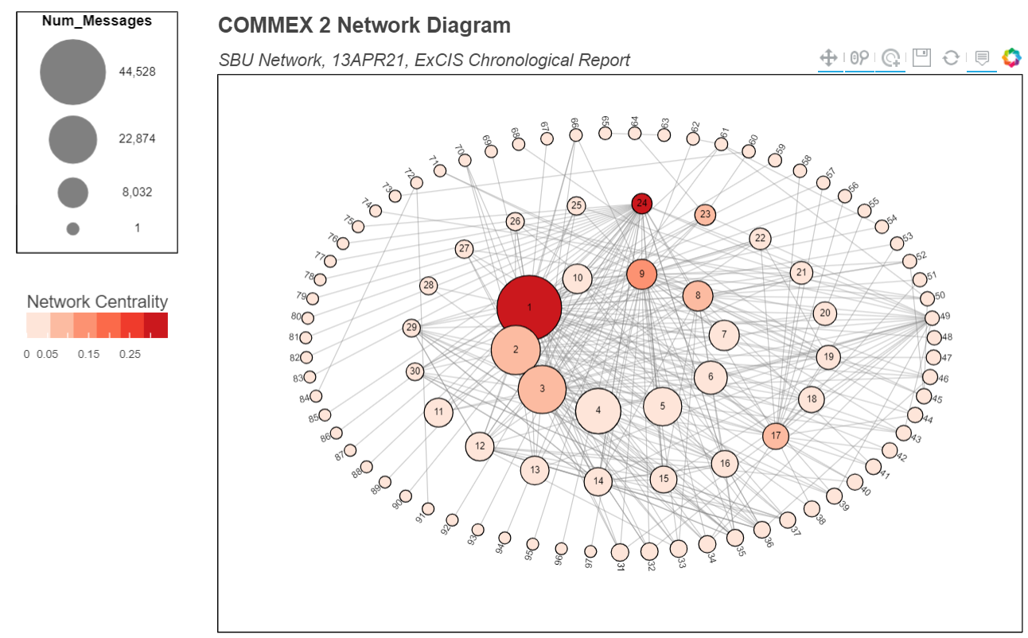
Figure 7: Network Criticality Diagram built from a PC Communications Exercise (COMMEX)

This graphic measures two aspects of node criticality. The first is node size, which indicates the number of messages handled by each node. The second is the node color, which indicates the node’s network betweenness centrality. While many centrality measures could be used, we chose this one as it gives a good indication of how critical each node is to enabling information flow across the network while providing connections to all the network nodes. As an example, node 24 has a high criticality score despite handling only a moderate amount of traffic. As shown in an alternate network topology in Figure 8, we see that node 24 provides the only conduit to a collection of nodes in the upper-left.

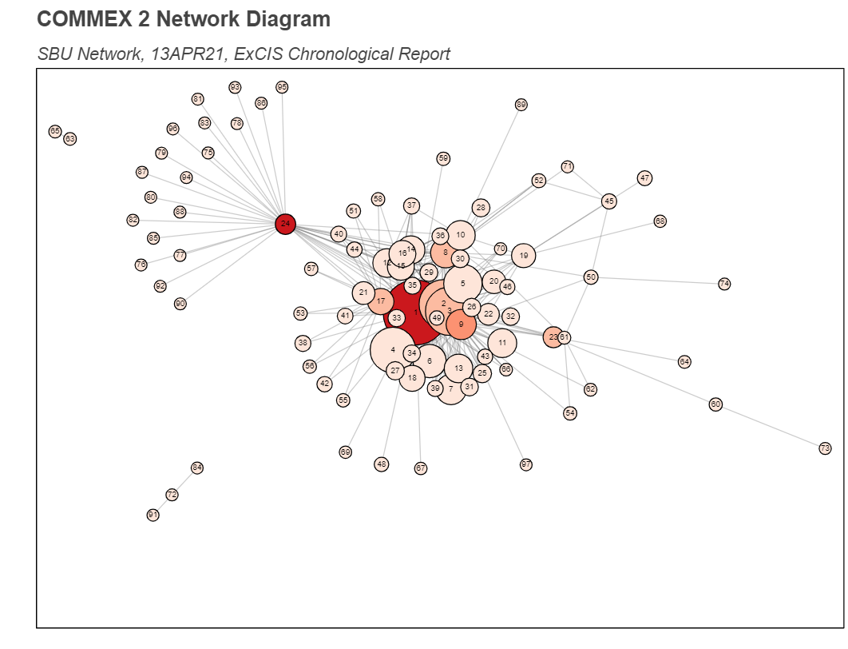
Figure 8: A spring layout of the same network diagram from the PC COMMEX.

Hence, the network criticality diagrams give a useful indication of each node’s criticality in terms of enabling data flow across the network. This gives exercise planners insights into network performance, while also supporting risk assessments by identifying which nodes are most crucial to ensuring successful execution of the experiments. In addition, this view can help provide the ability to identify network connectivity issues and address them in a timely manner. More broadly, these network diagrams also help to illustrate the overall health and performance of the tactical network. Since the ability of DoD systems to share information reliably is essential to effectively use AI/ML capabilities in battlefield formations, this type of view of network performance is a key insight to have during the PC experiment.

Sentiment Analysis
One key data source on system performance during Project Convergence are comments by observer/analysts (O/As) out in the field. These comments are manually entered into data cards during all use case runs, as well as during excursions, which were exercise variations of the primary use cases. As subject matter experts on the tactical setting or in the technological domain, the O/A’s were able to provide valuable insights into the performance of individual technologies or the operational effectiveness of the combined system of systems. Once these comments were collected, there were handed off to a data entry specialists, and then entered into the appropriate data repository based on the classification level.
Crucially, these O/A comments were available for analysis within hours or the next day, and thus provided a valuable opportunity to provide in stride analysis into system performance during use case runs. While the natural language processing (NLP) capacities were limited on classified networks, we were able to utilized the SentimentAnalysis package from the R ecosystem to provide preliminary analysis regarding whether the O/As has positive or negative assessment of each technology under evaluation. An example notional diagram is shown in Figure 9.
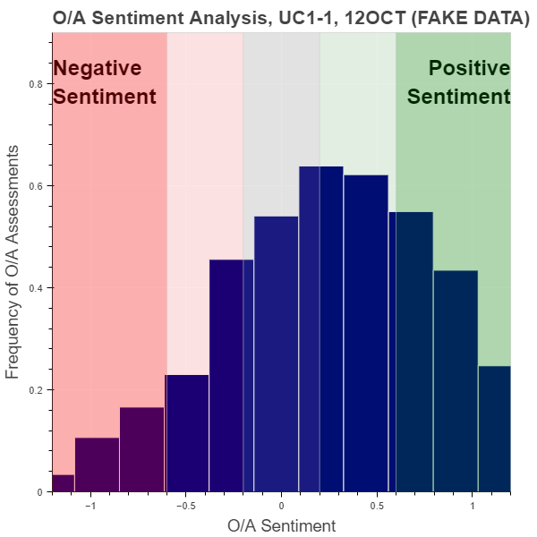
Figure 9: Notional example of using sentiment analysis to convey the assessments of O/As on the performance of systems under evaluation during a PC21 use case.

In addition to providing a quick measure of system performance, this type of sentiment analysis is also especially relevant for Project Convergence. User sentiment is critical for AI technologies, as highlighted by a recent survey where several Marines expressed a low level of confidence in existing AI/ML weapons systems and assessed high levels of associated risk for civilian casualties or other unintended consequences (Johns Hopkins APL, 2021). Hence, while the sentiment analysis conducted for PC in stride analysis was only preliminary, this is a promising area of research, particularly with regards to the evaluations of warfighting experiments involving AI/ML technologies.

CONCLUSIONS
Project Convergence is a crucial warfighting experiment to test the integration of AI and other emerging technologies while ensuring the continual advancement and modernization of the Army. In stride analysis provided during the PC experiment can not only inform senior leaders on the performance of the systems under evaluation, but can also yield insights and highlight issues that can help exercise planners identify and address issues, ensuring successful execution and data collection.
This research presented a methodology for conducting in stride analysis during project convergence, centered around the collection of packet capture data from the tactical network along with manual collection of observer comments and Execution checklist times; the aggregation and analysis of the multiple data sets; and the production of interactive web-based graphics which provide a flexible and powerful means of communicating results to key stakeholders. Additionally, we demonstrated several graphics tailored to deliver insights that would be useful and informative during the execution of experiments.
While the in-stride analysis methodology and the products were tailored to the challenges presented by Project Convergence, the concepts presented here would be relevant for many types of warfighting experiments. In many other operational test and evaluation settings, it would be useful to have near-real time analysis to support daily briefs, provide preliminary insights on system performance, assess progress toward addressing learning demands, or enable discussions about emerging issues or concerns. In particular, for experiments that aim to address the impact of AI technologies on battlefield formations across the joint force, timing analysis can illuminate the impact of AI sensors or decision agents, network criticality diagrams can highlight the performance of the tactical network that delivers the information to support the AI/ML algorithms, and sentiment analysis can yield insights into the level of trust and confidence users have in the underlying technologies. Ultimately this type of in stride analysis delivers data-driven and actionable insights which can enhance modernization and support the Army’s campaign of learning.

References
Hoehn, J. R. (2022). Joint All-Domain Command and Control. Congressional Research Service. Retrieved from https://crsreports.congress.gov/product/pdf/IF/IF11493
Johns Hopkins APL. (2021). Artificial Intelligence, Decision Support and Next Generation Intelligence.
Kenneth D Renard, J. R. (2015). High-Bandwidth Tactical-Network Data Analysis in a High-Performance-Computing (HPC) Environment: Introduction. US Army Research Laboratory.
TRAC, US Army. (2020). Project Convergence 2020 (Evolution I) Integrated Analysis Report.
US Army TRADOC. (2018). TRADOC Pamphlet 525-3-1, The US Army in Multi-Domain Operations, 2028.

List of Acronyms
AFC  AI/ML | Army Futures Command  Artificial Intelligence / Machine Learning
ARL-CISD | Army Research Lab – Computational and Information System Directorate
CFT | Cross-Functional Team
D3A | Detect-Decide-Deliver-Assess
DDIL | Denied, Disrupted, Intermittent, and Limited-Bandwidth
ExCheck | Execution Checklist
EXCON | Execution Control
HPC | High Performance Computing
JADC2  O/A | Joint All Domain Command and Control  Observer/Analyst
MADE | Modernization App Development Environment
PC  PC21 | Project Convergence  Project Convergence 2021
SME | Subject Matter Expert
TDL | Tactical Data Link

